Responding to student needs and expectations in the Library:
Electronic access to essential reading material

Elizabeth Murphy
Project Director & Head of Reader Services
The Library, National University of Ireland Maynooth
Maynooth, Co. Kildare, Ireland
00353.1.7083883
Elizabeth.Murphy@nuim.ie

Abstract

The Core Text Project at the Library, National University of Ireland Maynooth is a SIF-funded project that aims to give 24/7 access to as much core full-text student reading material as possible.
It seeks to address two specific expectations:
- that there are enough copies of essential reading materials in the Library to provide for the needs of each individual student
- that access to essential reading material be tailored to the specific needs of distance and part-time students
This paper will outline the project, evaluate progress to date and explore its future development.

Introduction

The John Paul II Library, National University of Ireland Maynooth (NUIM) serves a student population of approximately 8,400 students. As is the experience of most higher education libraries, meeting the expectations of students around the provision of essential reading material is a continuous challenge.

The Strategic Innovation Fund (SIF) was established in 2006 by the Minister for Education and Science to support innovation in higher education institutions in Ireland. As part of a total spend of €510/£400m¹ spread over 7 years, the first call for proposals was made for a fund of €42/£33m. “Enhancing teaching and learning” was one of the four key areas targeted (HEA, 2008).

In line with its Strategic Plan, the Library (2006) put in a successful bid in May 2006 under this theme proposing the appointment of “a suitably qualified person” to establish an “appropriate and innovative service” that would “address and manage student expectations in this area” (Neligan, 2006). This was also very closely aligned with the University’s Teaching and Learning Strategy (NUIM, 2007) and Strategic Plan (NUIM, 2006).

__________________________________________________________________________
¹ Currency calculations are based on exchange rates on 17 August 2008. All figures are rounded.

Conception to Implementation

As part of the implementation of the Library’s Strategic Plan, the Student Reading Team was set up to progress this project. It has strong representation from Reader Services because of the department’s existing responsibility to maintain the Reserve and Short Loan Collections.¹ There is representation from the Acquisitions Department because of its role in applying related collection development policies and the Systems Department because of the need for expertise in the application of technology.

Diagram 1 illustrates the project management model adopted by the team. Key features of this model are the scoping stage before any detailed planning takes place and the two stages for assessing the feasibility of the project prior to implementation.

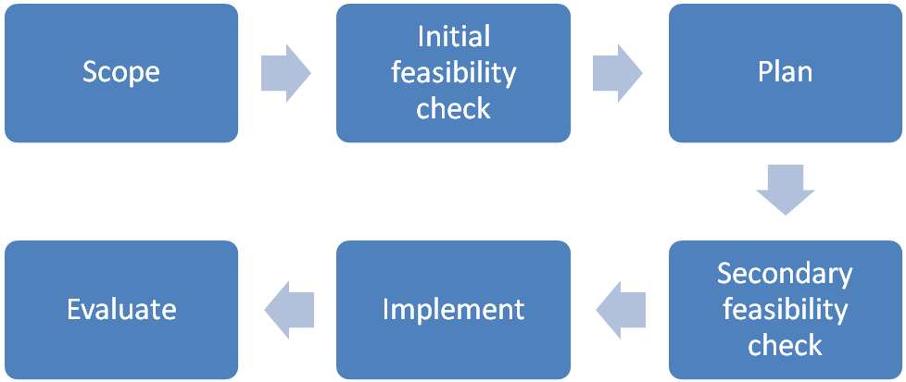

Diagram 1 – Project management model

The team began by scoping the project. This involved outlining the issues the project seeks to address, identifying the stakeholders, their needs and expectations, defining the aim, objectives and expected outcomes. The result was a clear understanding of the project rationale that gave structure, direction and focus to the planning and implementation stages.

The aim is to provide 24/7 access to as much core text material as possible by December 2008. The aim and objectives were underpinned by 2 guiding principles that were to inform decisions throughout the project:
- To prioritise solutions with maximum impact
- To ensure long-term sustainability and mainstreaming

It was at this stage, that the decision was taken to focus primarily on achieving electronic access and to by-pass any formal links to reading lists. The reason for this is the difficulty, based on past experience, of acquiring reading lists in a comprehensive manner and the effect this might have on progress. It was also felt that this decision could easily be reversed at a later stage, thereby further enhancing access to core text material.

__________________________________________________________________________
¹ The Reserve Collection is essential reading that is available for loan for 3 hours in the Library. The Short Loan Collection is essential reading that is available for loan for 2 days or a week

Planning

In February 2007, the Library received confirmation that funding had been granted for €56,000/£44,000 with the understanding that the Library would commit the same amount. With this in place and the project scoped and assessed, the Library’s Management Team gave the go-ahead to bring the project to the next stage.

Having explored all the options, the team recommended the appointment of a Project Manager for one year at Assistant Librarian grade as the most effective use of the funding. The post was advertised in April 2007. The successful applicant had the right combination of both library and computing experience.

The Project Manager started in August 2007 by preparing a detailed project plan and presenting it to the Management Team for review. The Management Team agreed the plan and the project moved to the next stage – implementation.

Implementation

The first task was to raise awareness of the project. In addition to emailing academic staff directly, this was done through the Library’s newsletter, the website and the Library’s space on Moodle, the University’s virtual learning environment (VLE).

The next few months were spent researching and putting procedures in place. At this point, it was decided to run a pilot in parallel with other solutions. The Sociology Department was chosen because of the number of students served by the department and its proactive relationship with the Library.

Each procedure is documented in detail. This is vital for training existing and new staff, for keeping track of progress and for future evaluation. Diagram 2 gives an indication of the workflow that has evolved to date.

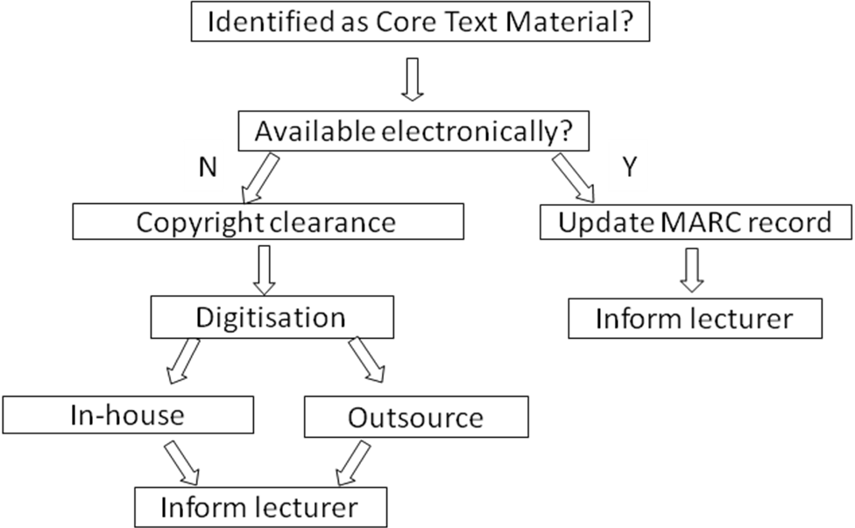

Diagram 2 – Workflow

- Identifying core text material
During the scope of the project, core text material was defined as material that students are required or expected to read. This definition excludes other additional recommended reading. Core text material is identified from 5 sources:
- all new material submitted by academic staff for addition to the Reserve and Short Loan Collections
- new book orders submitted by academic staff identified as core text via a tick box added to the order form
- new book orders for multiple copies submitted by academic staff
- the existing Reserve Collection in retrospect
- a list of material identified as core text compiled by the Sociology Department as part of the pilot

- Sourcing material electronically
Once material is identified as core text, the next step is to source the material in electronic format. The following resources are searched:
- the Library’s subscribed databases of full-text electronic resources
- the University’s institutional repository
- databases of electronic material that are freely available
- database catalogues
If the print version is already held by the Library, a link to the electronic version is added to the catalogue record. Otherwise, a catalogue record is imported or created.

- Copyright clearance
If material is not readily available in electronic format, copyright clearance to digitise is sought via the Digital Extension to the Higher Education Licence issued by the Irish Copyright Licensing Agency (ICLA, 2007) or directly from publishers. Due to the current limitations of the digital licence, copyright clearance is more often sought directly from the publishers.

Typically, this involves a copyright fee based on the number of students that need access to the material, the number of pages involved and the length of time for which the material is required. In situations where copyright clearance is denied, most copyright holders are willing to allow between 10% and 20% of the material to be digitised.

- Digitising the material
The next step in the process is digitising the material. Material less than twenty pages is scanned in-house, otherwise it is outsourced. In both incidences, the material is scanned at a resolution of 300 dots per inch. The text is converted to searchable text using optical character recognition and the file is saved in portable document format (PDF).

When the material has been scanned, a template is inserted at the start of the PDF file giving bibliographic details, module and lecturer details and any appropriate credit lines or copyright notices that need to be included. For example, “Reproduced with permission of…” or “The download of this file is intended for the user’s own and personal and non-commercial use…”.

Using LEFT, free software to facilitate data transfer, the file is sent to the lecturer for uploading to the module space on Moodle. Access to the material is only available to the students registered for the relevant module. This fulfils the terms under which permission is granted to digitise the material.

Evaluation

There are now 227 core text items available electronically. Of these, 33% are books,
37% are chapters and 30% are journal articles.

Diagram 3 - Items available electronically by format

- Sociology Pilot
The list of core text material comprised 67 (20%) journal articles, 89 (26%) books and 185 (54%) book chapters totalling 341 items.

Diagram 4 – Availability of Sociology core texts by format

Of the 67 articles requested, 59 (88%) were found electronically and are now available via the library catalogue.

Of the 89 books listed 21 (23.5%) were available electronically and can be accessed via the library catalogue.

5 (3%) of the 185 chapters were already available electronically. 24 (13%) received permission to be digitised and can now be accessed via the Sociology Department’s space on Moodle.
- Feedback
Overall, feedback has been very positive. Usage reports are indicating a high level of usage. Academic staff is reporting that material on Moodle is being used at all times of the day, night, and week, even on Christmas Day!

Students are using the Library’s facility to download this material to their MP3 players. Having the material accessible electronically is offering greater flexibility for users with disabilities.
“It ties in well with the culture and expectations
of our talented and tech savvy iPod generation students.”
(Mr Tom Mulvey, Department of Business and Law)

In addition, the Library’s profile has been enhanced, particularly amongst academic staff.

"Easy and open access to essential readings
will greatly improve lecturers' ability to design innovative courses
and will provide students with a greater range of readings
and of ways to get access to them.”
(Prof. Sean Ó Riain, Department of Sociology)

Library staff is also pleased with the development opportunities this project has provided.

- Costs
Costs for the project consist of three main factors: the subscription fee, the copyright and digitisation fees and staff resources. Some examples:
- Subscription fee – the average cost of an electronic book (e-book) sourced through NetLibrary is €100/£80
- Copyright clearance fee – an average is €165/£130 charged for a chapter of 22 pages
for 191 students. The cheapest to date has been €70/£55 for a book of 422 pages for 30 students. The most expensive has been €2,590/£2,040 for a book of 399 pages for 95 students. Needless to say, this book did not get past this stage!
- Digitisation fee – the in-house costs are the staff time involved. Outsourced digitisation is charged at 12c/9p per page.
Diagram 4 illustrates the comparative costs based on a chapter that was digitised in-house (€230/£180), a book that had its digitisation process outsourced (€130/£100) and a book that was available electronically (€100/£80).

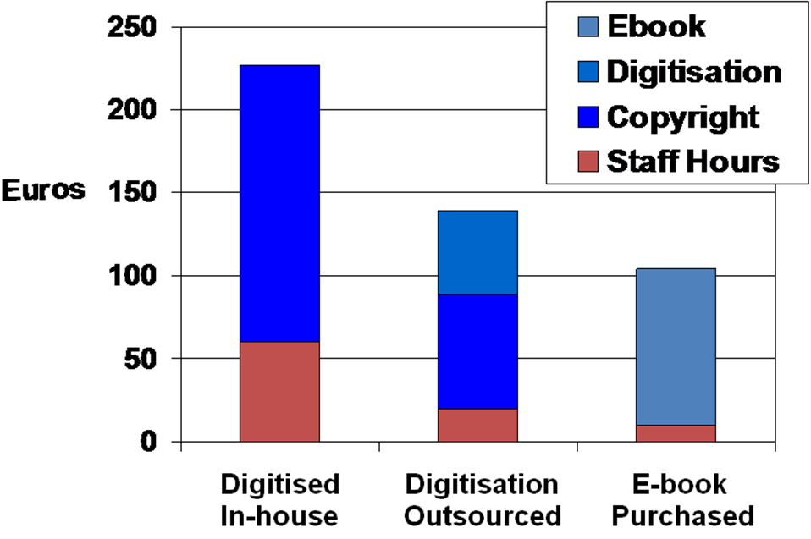

Diagram 4 – Comparative costs
The project has highlighted the lack of electronic availability of core text items published in Ireland. The Digital Extension to the Higher Education Licence (ICLA, 2007) enabled two chapters to be digitised. Most Irish publishers have not been keen to grant permission to do this. The cost/benefit ratio regarding material requiring digitization may change if the licence is expanded as expected. In addition, as more and more material becomes available electronically, there may be less need to digitise and a reliance on a service such as HERON¹ could become more attractive.

- Integration as a service
4.1) Terminology
The terminology is gradually taking on new meaning to reflect the full integration of this project as a service. For example, the electronic versions of core text material are collectively referred to as the Core Text Collection whereas the Reserve and Short Loan Collections refer to the print versions of core texts.

4.2) Integration with other library functions
Up to now, the Library subscribed to e-book packages and occasionally purchased individual titles whenever an e-book was specifically requested by academic staff. The Core Text Project added yet another dimension and highlighted the need to coordinate activities in the acquisition, management and delivery of e-books in general. The Library has decided to move forward by using the Core Text Project as a pilot for the expansion of the Library’s e-book collection. The final report of the Core Text Project will also make recommendations to guide library policy in this area.

4.3) Access to e-books
The Core Text Project has also been the catalyst for the Library’s decision to make all individual e-book titles accessible via the catalogue. The catalogue will become the one central point to locate information on the availability of e-books. Titles for which access is restricted by the licence to a fixed group can be stored and accessed via space in Moodle.

- Project to Service
Before the Core Text project concludes, the following areas need to be investigated:
- A more reliable procedure for uploading files to Moodle
- A link from the catalogue to Moodle
- Collection maintenance procedures
- Better usage statistics
- More qualitative feedback from users
- More sources for e-books

_________________________________________________________________________
¹ HERON is a copyright clearance and digitisation service. http://www.heron.ingenta.com/

Future development of the service

As the Sociology pilot has highlighted, a large proportion of core text material comes from books rather than journals and yet journal articles are more readily available in electronic format. While the evaluation of this project has been very encouraging to date, the success of its future will also be determined by the growth and development of e-books and how students will engage with them. There have been a number of research projects (JISC, 2008: mostly on the usage and impact of e-books, whose findings act as useful indicators of how that future might look:

- The most successful discovery tool for e-books is the library catalogue thus affirming the Library’s decision to catalogue each e-book title whether purchased individually or as a part of a package
- Part-time students are more likely to use electronic resources provided by the library than full-time students which confirms that the needs of the ever expanding numbers of off-campus students can be met by the provision of core text material electronically
- Usage on Sundays has proven more popular than Saturdays with Monday being the most popular weekday indicating the improved access to core text material by making it available electronically
- The high level of sharing and multiple use of core text material prevalent in the print environment that is mirrored in the electronic environment verifies the need for the library to continue its role in the provision of core text material
- E-book users tend to dip in and out of sections rather than reading them sequentially which may change the way students fundamentally engage with books
- E-book collections are now being marketed as e-content collections that include book chapters, journal articles, encyclopedia articles, sheet music, maps, reports and audio-books. This will create more opportunities for customisation and personalization of collections of core text material
- Usage of electronic journals (e-journals) is usually concentrated in most recent articles whereas usage of e-books spans much older material which will have implications for licence agreements and the management of e-books collections
- A proportion of students seem unaware of e-book collections and less comfortable and skilled in using them than e-journals. The Library can assist students in this regard by more targeting marketing and training
- The trend in libraries not to maintain a print version of an e-book for which they have access will place extra demands on the campus IT infrastructure
- Some libraries digitize out-of-copyright books in order to make contents more available to library users – this is justification to continue the digitization for out-of-copyright material.
- Consortial purchasing is best directed towards negotiating agreements with a number of vendors and seeking a discount on access and platform fees rather than a consortial collection. There is potential for Irish libraries to collaborate towards achieving more favourable fees and a more standardized approach to license agreements

In addition to these findings, there are other factors influencing the future of the service:
- The growth of mobile technology may necessitate alternative formats as PDF is not the most suitable for anyone wishing to convert files to make them more accessible for their particular needs or to download files to mobile phones and iPods
- While there is currently adequate storage space on Moodle, if the amount of material provided via Moodle grows considerably, extra storage space will need to be investigated
- Staff has been restructured to provide additional resources to the project. This may need to be sustained in order to maintain and develop the service
- As current expectations are addressed, new expectations will emerge. For example, students may expect the Library to provide e-book readers

Conclusion

Answering the question – “is this project worthwhile?”, the response is very definitely “yes”.
It is succeeding in achieving its aim and objectives and ultimately addressing the needs of the students and fulfilling expected outcomes.

Furthermore, it has the potential to develop into a key and valuable service for the foreseeable future.

Acknowledgements

Laura Brett, Project Manager, August 2007-March 2008
Marie Cullen, Project Manager, March -June 2008
Pauline Murray, Project Manager, September-December 2008
Emma Boyce, Della Webb and Louise Saults for their continued hard work and commitment to the project.

This article is an expanded and updated version of an article submitted to SCONUL Focus, 2008, No.43.

References

HEA (Higher Education Authority) (2008), Strategic Innovation Fund, Dublin. http://www.hea.ie/en/sif - accessed 17 August 2008.

ICLA (2007), Higher Education Licence: digital extension. http://www.icla.ie/index.php?education_highereducation – accessed 17 August 2008

JISC (Joint Information Systems Committee) (2008), JISC national e-books observatory project: first user survey. http://www.jiscebooksproject.org/deep-log-analysis - accessed 4 August 2008

Library, NUIM (2006), The Library Strategic Plan 2006-2008, p.9. http://library.nuim.ie/about/publications.shtml

Lonsdale, Ray and Chris Armstrong (2008), ‘Aggre-culture: what do e-book aggregators offer?’, Library and Information Update, 7(4), pp 28-33

Neligan, Agnes (2006), Outline proposal – reading strategy for students, 16 May 2006 (internal document)

Nicholas, David, Paul Huntington and Ian Rowlands (2007), ‘E-books: how are users responding?’, Library and Information Update, 6(11), pp 29-31

NUIM (2006), University Strategic Plan 2006-2011. http://corporateservices.nuim.ie/

NUIM (2007), Teaching & Learning Strategy. http://qpo.nuim.ie/teaching/index.shtml

Shepperd, James A., Jodi L. Grace and Erika J. Koch (2008), ‘Evaluating the electronic textbook: is it time to dispense with the paper text?’, Teaching of Psychology, 35(1), pp 2-5

