The Entrepreneurial Ecosystem and Irish Third Level Education:
A case study of an undergraduate programme.

Therese Moylan, Orla Byrne and Conor Heagney
School of Business & Humanities, Dun Laoghaire Institute of Art, Design & Technology (IADT).

Introduction
This paper looks at the relevance of the entrepreneurial ecosystem to Irish third level education. The first part of the paper examines the development of entrepreneurial ecosystems while the second part is a case study of the experiences of one programme in Ireland.

Development of Entrepreneurial Ecosystems in Education
What role if any do educators have to play in developing entrepreneurship? The recent report from the EU (2006) on entrepreneurship in Higher Education highlights the importance of education in the promotion of more entrepreneurial attitudes and behaviours and refers to the challenge of stimulating entrepreneurial mindsets in young people. In particular it notes that at third level the primary purpose of entrepreneurship education should be to develop entrepreneurial capacities and mindsets and advocates an action learning approach. The report (2008) emphasises the need to use experience based teaching methods in order develop entrepreneurial thinking and states explicitly that “traditional educational methods (like lectures) do not correlate well with the development of entrepreneurial thinking”. It follows then that traditional modes of assessment (like exams) do not facilitate the development of entrepreneurial attitudes and behaviours.

Similarly Gibb (2002) expounds a view that questions traditional educational methods in the context of developing entrepreneurship. He argues that “entrepreneurship can play a significant role in a range of very different environments in societies across the world, within and between countries and cultures”. However, he suggests that the traditional ‘paradigm’ of entrepreneurship education would need to change in order to facilitate that. He implies that entrepreneurship that exists solely in the dimension of business schools is too narrow, and hinders its ability to address major issues in society, particularly in developing countries. Gibb (2002) refers to this as the ‘institutional’ dominance of the USA business schools. It is influenced considerably by the dominance of the historic economic literature combined with the largely corporate business school approach and is almost exclusively business management focused. The question lies as to whether this model can meet the challenges of modern society.

The alternative of model of entrepreneurship education, promoted by Gibbs and supported by the EU report, moves towards a broader societal model of entrepreneurship, which places emphasis on the values of entrepreneurship and developing entrepreneurial behaviours, attributes and skills encompassing concepts such as emotional intelligence, vision, holistic management and the ability to build trusting relationships. This scenario translates into a need to equip individuals with personal entrepreneurial capacities and to design organisations of all kinds, public, private and NGO (non-governmental organisations) to support effective entrepreneurial behaviour. Therefore the new challenge for entrepreneurship education is that it needs to address a number of personal, organisational and societal capacities. This in turns challenges educators to develop modes of teaching and learning that support the development of these capacities.
Existing models of entrepreneurship education fall somewhat short in developing these capacities. The Harvard view of teaching entrepreneurship is highly case focused (Harvard Business School 2005). Yet entrepreneurial behaviours, skills and attributes, nurtured by well designed pedagogies and exposure to experience are essential components of being able to ‘feel’ what it is like to be entrepreneurial and are arguably key to the creation of entrepreneurial values through learning (Gibb 2002)
At the heart of a more innovative approach to entrepreneurship education is creating an opportunity for students to feel entrepreneurial and this requires a teaching methodology which creates opportunities for students to “learn by doing”. It recognises that knowledge is not learning until is in some way internalised either by application or thinking. Very often, this internalising is achieved by “doing”. This approach creates very real challenges for higher educational institutes as entrepreneurial learning can be seen as a process of trial and error and incremental improvements, something that can be hard to accommodate within traditional academic curriculum.
Conventional models do not easily meet the broad needs that are required for the entrepreneurial society. ‘There has to be a wider context than business, an holistic approach to knowledge, a strong emphasis upon pedagogical variety and experiential learning, understanding of how to design entrepreneurial organisations of all kinds and, in terms of outcomes, a stronger focus upon creating empathy with the entrepreneurial mindset’. (Gibb 2002). The development of an entrepreneurial ecosystem is designed to contribute to achieving such goals.
Definition of ’entrepreneurial ecosystem
The term ecosystem as defined in the Concise Oxford English Dictionary refers to “a biological community of interacting organisms and their physical environment”. While having its roots in the biological and natural world the term has come to be used in wider contexts when describing a community of interacting entities and individuals who are engaged in related activities in a manner that is mutually supportive. Indeed, the term has also been commandeered by the business strategists – James Moore writing in the Harvard Business Review in 1993 coined the term “business ecosystem” describing it as “An economic community supported by a foundation of interacting organizations and individuals--the organisms of the business world”. He goes on to note that over time the member organisations “co-evolve their capabilities and roles, and tend to align themselves with the directions set by one or more central companies”. Thus it can be said that the ecosystem approach offers a framework within which to view the interactions between individuals / organisations and their environment.
In the study of entrepreneurship, the notion of an entrepreneurial ecosystem provides an interesting perspective from which to analyse the emergence of entrepreneurs from either regions or from institutions. Valdez has proposed that the entrepreneurial ecosystem model be used to explore the relationship of new business formation to the economic environment. There is also considerable discussion around the concept of an entrepreneurial ecosystem being regionally based, with areas such as the Silicon Valley on the west coast of the US being touted as have a particularly supportive ecosystem for technological orientated entrepreneurs, while Ramadorai (2008) advocates the need to build a more supportive ecosystem in India to facilitate the entrepreneurial mindset that is evident there.
Increasingly the concept is found in the literature on entrepreneurship education and interestingly, to date much of the discussion has centered on the development of an entrepreneurial ecosystem for technology and engineering disciplines.

What does a higher education entrepreneurial ecosystem look like?
Engel and Charron (2006) from the Lester Centre for Entrepreneurship and Innovation acknowledge that an institution cannot plan entrepreneurship; however, it can support pedagogy, skills development and good relationships, all of which are elements of the entrepreneurship education. Much of their work concentrates on technology entrepreneurship with many of their students studying at postgraduate level. The components of the ecosystem are built from a strong entrepreneurship curriculum and include the following:
- Creating multidisciplinary and inter institutional links
- Attracting and integrating the enterprise community into the campus
- Building networks of mentors
- Using competition including business plan competitions
- Creating an integrated approach to entrepreneurship

In the context of their work with potential technology entrepreneurs, they depict the Entrepreneurial Ecosystem for their context as shown below. Underpinning their approach is the objective of facilitating start ups with by combining teams of knowledge workers and appropriate technology in an enabling environment which fosters commercialisation and growth.
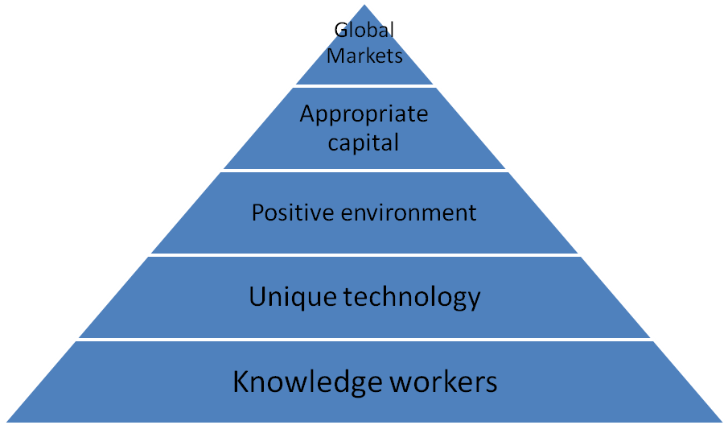
Programme relationships
University Research and corporate partners
Entrepreneurship education
Networks of relationships
Mentors and advisors

Fig. 1. The Lester Centre for Entrepreneurship and Innovation Entrepreneurial Ecosystem.

The above model sits very comfortably with what is recognised by other higher education providers as part of their ecosystem. Writing in Xconomy, Swift (2008) states that universities offer a thriving ecosystem that lends itself well to supporting entrepreneurship among staff and students and describes technology transfer offices, business plan competitions, access to capital as important elements in promoting entrepreneurship in US institutions such as MIT and Sloan Management school.
What are the elements of the ecosystem that we are building in IADT?
What relevance if any does the concept of an entrepreneurial ecosystem have for an undergraduate programme in our Institution? On initial examination of the key principles (multi-disciplinarity, engagement with enterprise community, integration etc.) expounded by the Lester Centre and others are shared by IADT. However, there is a key difference in terms of the end objective – at the undergraduate level we are not concerned about facilitating immediate start ups. What we are trying to do is develop skills and competencies that are in keeping with the characteristics of an entrepreneurial mindset while imparting the knowledge relevant to potential future entrepreneurs. In this context, the alignment of programme outcomes and assessment procedures is pivotal and our Entrepreneurial Ecosystem is designed to support these.
Our teaching and learning approach, illustrated below is committed to providing a student centric teaching and learning environment which provides an opportunity for all students to apply what they learn in the class room to real world contexts. This is the approach advocated in the recent EU report and thereby fostering entrepreneurial attitudes and behaviours.

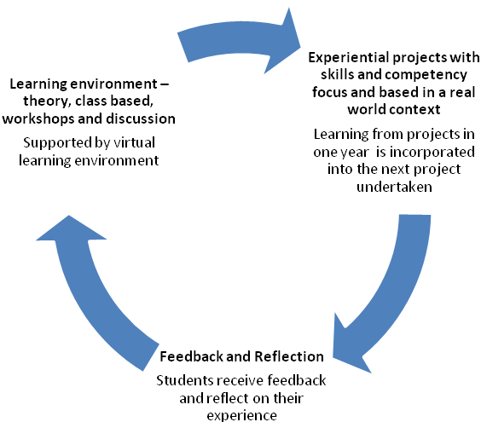
Fig. 2. Teaching and Learning Approach at Department of Business and Enterprise, IADT.

The IADT entrepreneurial ecosystem is depicted in figure 3 below. The remainder of this paper will focus on the core element of the ecosystem i.e. the relationship between programme learning outcomes and the assessment methods used to meet these. All of the other elements around the ecosystem only make sense if they are related t, and in some way support the core activity i.e. to meet the learning outcomes. The relational issues around these supports will be explored in a future paper
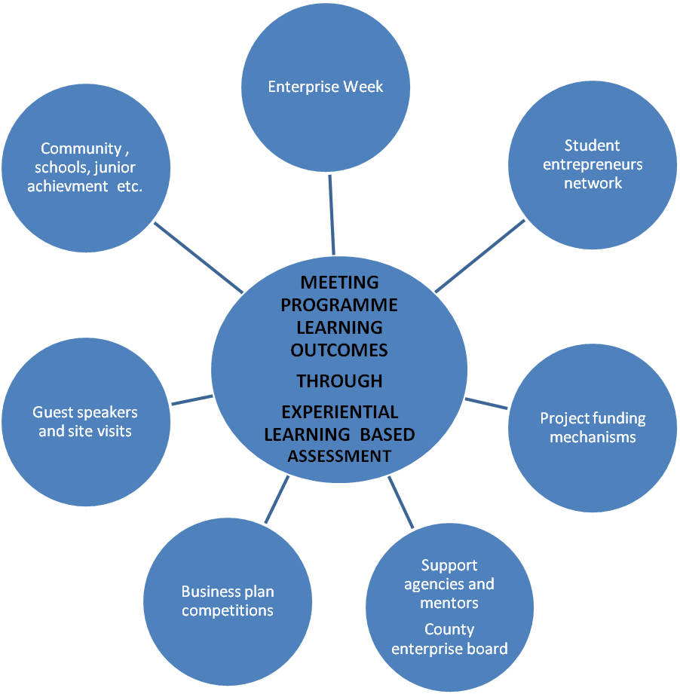
Fig. 3. The IADT Entrepreneurial Ecosystem.

The IADT Entrepreneurship Ecosystem - a case study
The Bachelor of Business in Enterprise (CAO code DL231) is a three year level 7 degree. The degree was first offered in 1998. Details of the programme can be accessed at www.iadt.ie . Our entrepreneurial ecosystem is 4 years old (started in 2004) and was developed in response to the introduction of the National Qualifications Framework (the framework). The process for the development of ecosystem is shown at figure 4. This process is based on Biggs’ (2003) theory of constructive alignment. The elements of the process are addressed below.

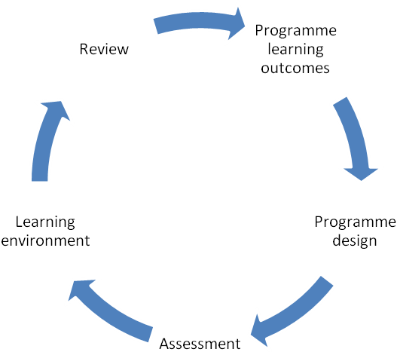
Fig. 4 Development process of the ecosystem.

Programme Learning Outcomes
The framework was introduced to the Institute of Technology sector in spring 2004. It sets out the learning standards for each level of award. Accordingly we had to specify programme learning outcomes under specified categories of ‘knowledge’, ‘know-how and skills’ and ‘competencies’. The programme learning outcomes follow below.
On successful completion of the programme, the graduate will be able to:
- have a developed and integrated knowledge of management, finance, information technology/systems and marketing (knowledge)
- integrate his/her knowledge across a number of business modules (knowledge)
- sell and promote goods, services and ideas (know-how and skills)
- prepare a business plan (know-how and skills)
- analyse, interpret and manipulate business data to solve specific business problems (competencies)
- work effectively as part a group in structured and non-structured environments (competencies)
- identify his/her own learning needs in the business environment and to design and implement solutions (competencies)
- appreciate social, community and ethical business issues (competencies).

The shift in emphasis from knowledge to skills and competencies is particularly relevant to entrepreneurship. The aim of the programme is to help students to ‘make things happen’ in their working lives as well as to foster a deep understanding of their environment. The need to create an entrepreneurial atmosphere for our students became clearer. Whilst we did not realise it at the time, the framework kick started our journey towards an entrepreneurial ecosystem.

Programme Design.
The programme operates in a modular environment. Previously there were a number of elective modules. No additional resources have been allocated to the development of the ecosystem. As the programme is a business programme, the (‘THAS’) formula for allocating resources means that funding is substantially less than, say, technology or art and design programmes.
The Programme Board made the following decisions:
- elective modules were removed so that all students studied the same modules. This greatly facilitated multi-module projects.
- new modules such as ‘Learning & Research Methodologies’ and ‘Critical Thinking’ were introduced. The purpose was to help in the development of the key learning competencies.
- the programme design to be reviewed annually (instead of every 5 years during the programmatic review). The reasoning behind this decision was that as the entrepreneurship world changes rapidly so should our ecosystem.
Assessment
How do we know that our students have achieved the varied and challenging programme learning outcomes? Previously we relied heavily (c. 65%) on end-of-year exams to assess our students. With the increased emphasis on skills and competencies, it was clear that a different approach to assessment was necessary. The following decisions were made:

- continuous assessment element for each module moved to either 50% or 100%. Currently continuous assessment forms 77% of all assessment on the programme. The increased level of continuous assessment facilitates feedback which is important in the fostering of skills and competencies.
- assessment across more than one module to be encouraged. As most of the programme learning outcomes span many modules, it is important to align assessment with these outcomes. The nature of entrepreneurship tends to span many ‘module areas’. In addition to the major projects (see ‘The Learning Environment’ below), there are a number of ‘minor projects’ spanning 2 and 3 modules.
- assessment is planned annually across the programme. An extern examiner has joined the programme team, for the 2008/09 academic year, to put together the assessment plan. This advance assessment planning facilitates the alignment of assessment across modules and across the three years of the programme.
The Learning Environment
The major change was the introduction of a major multi-module project in each of the three years of the degree. Such projects facilitate an “action learning” approach which is advocated in the EU reports and allows students to “feel” what it is like to be entrepreneurial, an objective lauded by Gibbs in his call for an alternative to traditional entrepreneurship education.
Year 1. Stalls Project.
Students, in groups of 5 or 6, run their own micro businesses and sell their products/services in a local municipal market. The businesses are funded by the students. As well as learning the theory of modules such as management, marketing, learning & research methods, and accounting, the students get a chance to put their learning into practice. Feedback is provided by lecturers from the perspective of each particular module. Students are introduced to many of their programme learning outcomes, financial and commercial risk and to the public.
Year 2. Online Trading Project.
Students, in groups of 3 or 4, run their own micro businesses and sell online using the eBay platform. The students are given an opportunity to apply their learning from the year 1 stalls project in the running of a different business. The modules involved in this project are; internet applications, marketing research, communications, organisational behaviour and accounting. Project funding of 3,000 euro was obtained from the Institute to provide loans of 200 euros to each trading group. Each group of students has to pitch for this loan funding before a panel of internal and external experts. eBay provide training and technical support to the students.
Year 3. Magazine Project.
A student group of 23 published a magazine. The students carried out every element of the business from conception to the distribution of 7,000 copies of the magazine. The students fund the magazine business. The modules involved are Enterprise Management and Finance. External experts are brought in to talk to the students as the need arises. The scale of this project is significantly larger than the earlier projects. However it is intended that the students will transfer their learning from the earlier projects and apply it to the magazine project. The financial and commercial risks are considerably bigger than the year 1 and 2 projects.

Summary of the Learning Environment.
The placement of a major project in each year is designed to create a flexible space where:
- Students can apply their ‘knowledge’ learning to real businesses
- Students are exposed to real risk, group work and unstructured problems
- Students can learn from one another (peer learning). This is further encouraged through the ‘student entrepreneurs’ network’ which provides active student entrepreneurs with an opportunity to meet.
- Innovation is encouraged
- Students get a chance to apply feedback from previous projects as the projects are designed to build on one another
- Lecturers have ready-made teaching, learning and assessment vehicles without ‘re-inventing the wheel’
- Students can showcase their learning achievements. ‘Enterprise week’ runs in January of each year. The stall project runs during enterprise week. Our local enterprise board in Dun Laoghaire strongly supports enterprise week and other parts of our entrepreneurial ecosystem
- Engagement with important stake-holders is facilitated. Groups from local primary and secondary schools can participate in various stages of the projects.

Review
The whole programme is reviewed annually by a number of stake-holders:
- Students
- Staff
- Extern examiners
- External advisory panel (currently being put in place). This will be made up of established entrepreneurs.
The high level of continuous assessment provides significant flexibility in dealing with developments in the learning environment. For example in 2008/09, the year 3 class will be bigger than usual so it will be necessary to run three separate projects within year 3. Every sustainable ecosystem constantly evolves and adapts to external changes. Likewise the review mechanism is essential to the sustainability of our entrepreneurship ecosystem. The high level of interaction and feedback, throughout the projects, means that the projects must be run efficiently. The annual review process plays an important part in balancing resources and educational quality in this context.

Conclusion
Where a programme purports to provide an entrepreneurship education, it is reasonable for students to expect not just knowledge but also the relevant skills and competencies. Our response to this challenge has been to develop our own entrepreneurial ecosystem. The heart of this ecosystem is a graduated series of micro business projects where students can mix knowledge with the ‘real world’ in a relatively sheltered environment. Our ecosystem is young (4 years old) and has to compete with more established ecosystems for food (financial resources) and sunlight (staff and student energy). As with every young enterprise, our ecosystem will have to fight hard to survive and grow. It is the hope of our programme team that this struggle will provide a rich learning environment for our students and that ultimately it will contribute to our students’ success in their future enterprises. Accordingly it is our opinion that the entrepreneurial ecosystem approach is worth considering where an undergraduate programme wishes to develop entrepreneurial skills and competencies.

Bibliography:
Biggs, J. 2003, Teaching for Quality Learning at University Second Edition, The Society for Research into Higher Education and Open University Press, Buckingham.
Gibb, A. 2002, "In Pursuit of a New Enterprise and entrepreneurship Paradigm for Learning: Creative destruction, new values, new ways of doing things and new combinations of knowledge", International Journal of Management Review, Vol.4 No.3, pp.223-69

EU Commission 2006, Entrepreneurship education in higher education institution: fostering entrepreneurial mindsets through education and learning, http://ec.europa.eu/enterprise/entrepreneurship/support_measures/training_education/doc/oslo_report_final_2006.pdf
Engel, J and Charron, D 2006, presentation at The Intel Technology Entrepreneurship Education Programme – Entrepreneurship Theory to Practice Seminars, Dublin
Moore, J 1993, “Predators or Prey: A new ecology of competition” in Harvard Business Review
Pearsall, J 1999, Concise Oxford Dictionary, Oxford University Press
Ramadoria, S 2008, Emerging Entrepreneurial Ecosystem in India, www.thesmarttechie.com/
Swift, Anne 2008, Universities: An Entrepreneur’s Ecosystem in Xconomy, www.xconomy.com

