An online survey to ascertain students’ experiences and expectations of academic practise and the virtual learning environment at GMIT

Dr. A. Brennan* & Rosie Curry**
GMIT

*attracta.brennan@gmit.ie
**rosie.curry@gmit.ie

ABSTRACT

“Quality teaching and learning, at both undergraduate and postgraduate levels, are at the core of the mission of the higher education institutions [HEA, 2008-2010]”. Recognising the position of the student as a major stakeholder, the relationship between students’ expectations and institutional deliverables is very complex [James, 2001]. James argues that whilst certain aspects of higher education cannot be validly judged by students, they are conversely well equipped to judge “the more tangible, short term components of the experience and to judge aspects of the process of higher education [James, 2001]”. These areas include the availability of IT support, student life, feedback, the teaching skills of the academic staff and the use and application of virtual learning environments etc. With regard to the latter, educational institutions are increasingly implementing online learning technologies as part of their growth strategy for the delivery of teaching and learning [Fannon, 2007]. Biggs points out that educational technology has great potential in helping educational institutions reach their aims and objectives “in managing learning, in engaging students in appropriate learning activities, in assessing learning and in enabling off campus learning [Biggs, 2006]”.

To identify students’ reactions to the VLE and to synopsise their expectations and experiences of academic practise, an online student survey was carried out in GMIT. The results of this questionnaire provided awareness of the students’ experiences of the VLE and their perception of the quality of teaching.

INTRODUCTION

The Irish government is committed to improving teaching and learning in higher educational institutions as evidenced by the investment of €510m over the six years of the NDP’s lifetime. “The role of the higher educational system is critical to Ireland’s future success [HEA, 2008]”. Indeed, the vision of the Higher Education Authority (HEA) for higher education in Ireland between 2008 to 2010 is to ensure that “the student is the central focus of all higher education activities [HEA 2008-2010]”. However this creates challenges, one of which is the need to adopt different modes of instruction in order to ensure effective teaching for a student body which is increasingly diverse in culture, age (widening participation) and learning approaches [Mohanna, 2007]. The efficacy, by which this and other challenges are addressed, will be determined by the ultimate arbiters - the students. James argues that whilst certain aspects of higher education cannot be validly judged by them, they are well equipped to judge “the more tangible, short term components of the experience and to judge aspects of the process of higher education [James, 2001]”.

Students “have things to tell us that only they can say with authority [Jackson, 2006]”.

SURVEY PROCESS

GMIT is a geographically dispersed college, with outreach campuses in Galway, Castlebar, Letterfrack and Mountbellew. As part of the marketing strategy, students who had fully completed the online survey were entered into a draw to win one of three ipods. With the co-operation of the IT staff, an animation - with an embedded link to the online survey launch page - was one of the first things that all students saw on logging into Moodle. This was active for the duration of the survey. To cater to those who did not use their Moodle accounts, emails were sent to the dispersed student population, with a link to the survey start page. The online survey was active for 3 weeks. Follow–up email reminders were deployed at the mid-way point. Whilst students were asked to provide contact details (i.e. mobile phone number), anonymity was respected, for as Kelly contends, “anonymous feedback results in responses that are more candid [Kelly, 2005]”.

BACKGROUND TO ONLINE LEARNING AT GMIT

The early adopters of Moodle - which was first piloted in GMIT in early 2006 and branded Learnonline - were a small group of about 30 lecturers. During the 2006/2007 Academic year, circa 80 lecturers had adopted Learnonline as an aid to their core course delivery. In the Academic year, 2007/2008 (the second year of full Learnonline implementation), this figure had risen to 130 lecturers. The aim for the Academic year 2008/2009, is to have 300+ lecturers proficient in the use of Learnonline and its extensive features. To meet this deadline, training courses have been and are being provided on a regular basis by IT staff.

WHY ONLINE LEARNING?

E-Learning or online learning refers “to the way people communicate and learn electronically [Roffe, 2002]”. The rapid growth and popularity in internet usage has meant that e-learning is an increasingly accessible delivery medium for education and training. In a university context, Ellis et al. contend that e-learning broadly refers to the use of technologies to support students in meeting their learning outcomes [Ellis, 2007]. In 2007 (in association with the Sloan Consortium), over 2500 American colleges and universities were surveyed about the nature and extent of online learning in their institutions. The results from this survey showed that the 9.7% growth rate for online enrollments had far surpassed the corresponding 1.5% growth rate of the overall higher education student population [Allen, 2007]. The increasing popularity of online learning is further reinforced by the fact that more than 66% of all higher education institutions in America now have some form of online offering for their students. The main drivers, as cited by American colleges, regarding the provision of online courses include; improved student access, attracting greater numbers of students, the provision of pedagogic improvements, improving the institution’s brand value and an increased rate of degree completion. Increasingly, the provision of online courses is being universally recognised as a critical aspect of both the long term survival of higher education institutions and their growth strategy in relation to domestic and overseas students [Hannon, 2007][Allen, 2007].

In December 2006, 591 American campus Information Technology leaders were asked to identify which IT related issues were most important for their institution’s success and also which IT related issue had the most potential to become increasingly significant in the near future. Course/Learning Management Systems were ranked in 9th place (the top issue being funding in IT) in answer to the former question and appeared in 7th place (the top issue being security) in answer to the latter question [Camp, 2007].

With benefits including accessibility, interactivity and the capability to self pace , “online learning is here to stay [Taylor, 2002]”.

STUDENTS’ VIEWS OF ONLINE LEARNING

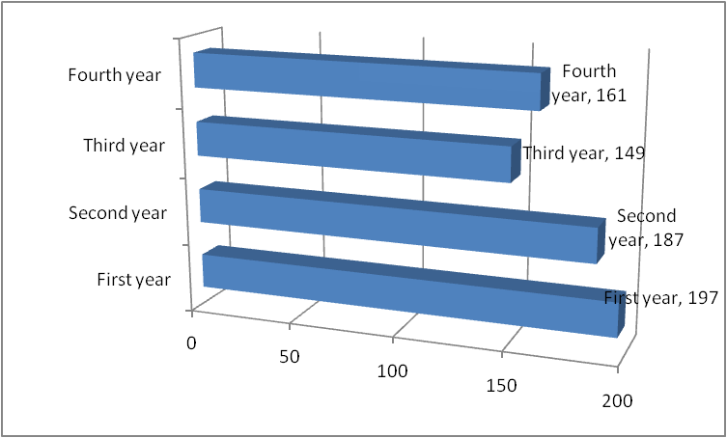
From an undergraduate student body of 4,889 students, across five geographically dispersed campuses, a total of 694 completed and usable questionnaires were received, yielding an overall response rate of 14.1%. Coming from a variety of very different disparate backgrounds (i.e. Engineering, Science, Hotel & Catering, Arts, Humanities, IT etc.), there was a fairly even spread of first, second, third and fourth year students participating in the online survey, with the majority of respondents being first year students (28%, 197) (figure 1).

Figure 1 : Year of study
Of those who responded, 81% (559) had used Learnonline (figure 2).
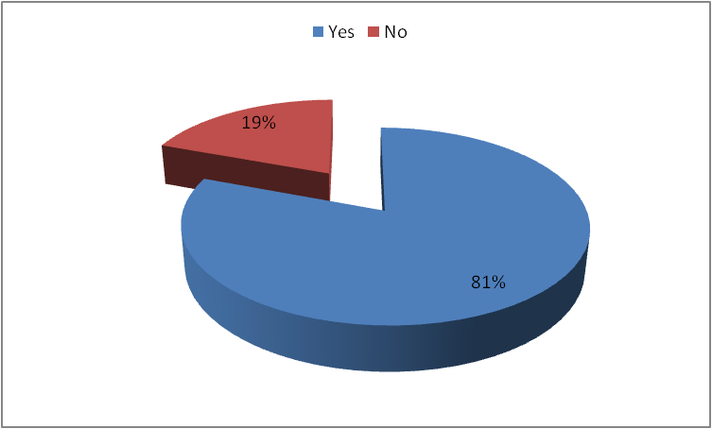

Figure 2 : Have you ever used Learnonline?

Of those who strongly agreed that Learnonline is easy to use (42%, 238) (figure 3), 29% were 1st years, 25.6% were 2nd years, 16.4% were 3rd years and 29% were 4th years. Of those who somewhat agreed that Learnonline is easy to use (48%, 265), 21.9% were 1st years, 35.5% were 2nd years, 19.2% were 3rd years and 23.4% were 4th years.
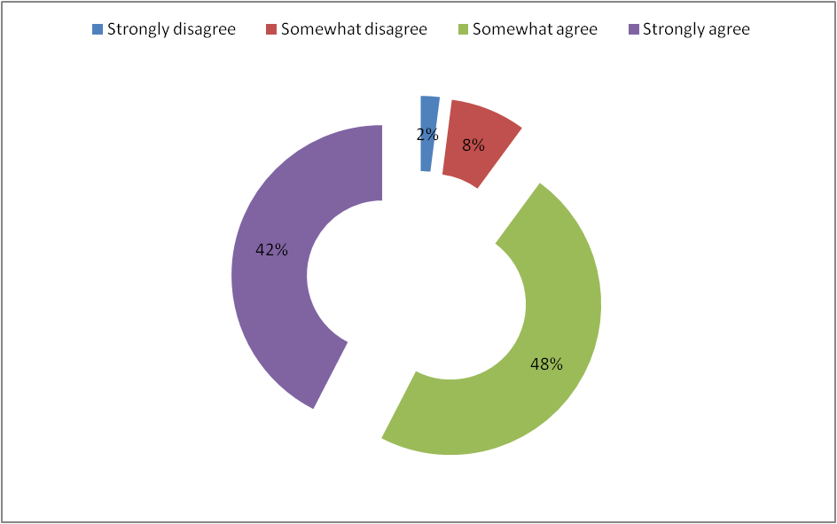

Figure 3 : Learnonline is easy to use

When asked about the manner in which they gained proficiency in Learnonline, the majority of respondents (60%, 335) said that they had learned through messing about on their own (figure 4).

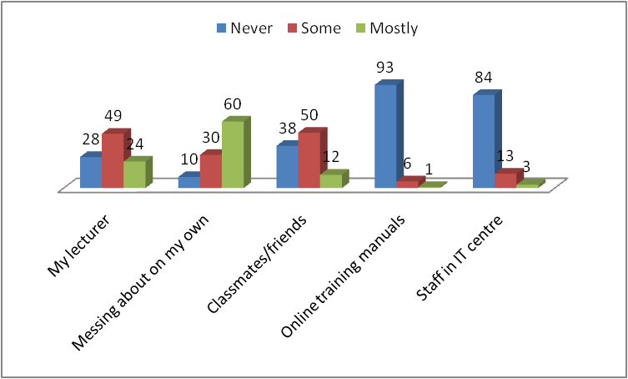
Figure 4 : How I learned how to use Learnonline

The features that the students most liked about Learnonline included; (note: these are the students’ own words) “it’s easy to use”, “all information is accessible quickly”, “it’s handy for college timetables”, “I can access subject information from outside the college computer network”, “e-mailing friends and using the Moodle system to contact class mates and lecturers is brilliant”, “it’s handy for getting notes or resources that lecturers put on the system”, “it gives useful information”, “it has everything you need to know about the college”, “it’s easy to submit assessments”, “it’s well organized”, “it presents relevant information”, “it encourages interaction between the lecturer and the student”, “it helps organize my study better”, “it lets students be more connected with classmates and lecturers”, “it helps us keeps track of course work”, “assignments and their due date can be seen all at once so enables you to keep on top of the work”, “it’s the easiest form of study in the college and because so many people use it regularly and know so much about it, if you needed any help you could just ask the person sitting beside you”, “many of my friends use it too so when we discuss work or projects in relation to Learnonline, it’s easy to follow the discussion and understand what each other is talking about”, “as a first year student with virtually no computer skills, I find it incredibly easy to use and work with which is great when you have enough to be doing.”

Of those who had experience of Learnonline, 86% (482) agreed that it helped their learning experience (the aggregation of the somewhat agrees – 72% (403) and the strongly agrees – 14% (79)) (figure 5). Of these 482 respondents, 134 are 1st year students, 145 are 2nd year students, 80 are 3rd year students and 123 are 4th year students.

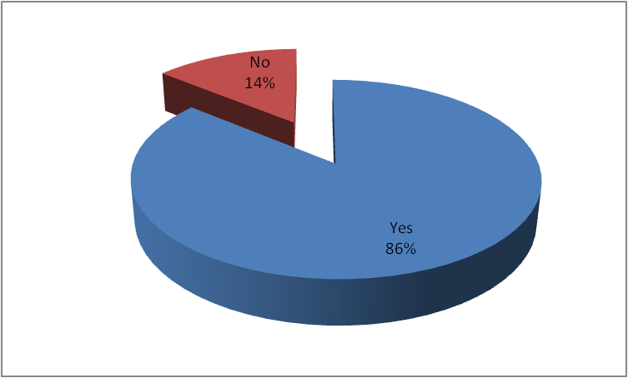

Figure 5 : Learnonline improved my learning experience

88% (496) of all respondents (on aggregation of the somewhat agrees (22%, 124) and strongly agrees (66%, 372)) agree that all lecturers should upload course content (i.e. structure, notes, resources etc.) to Learnonline (figure 6).

131 of the 147 1st years who had responded, 151 of the 168 2nd years, 89 of the 102 3rd years and 125 of the 143 4th year students firmly believe that all lecturers should be compelled to use Learnonline.
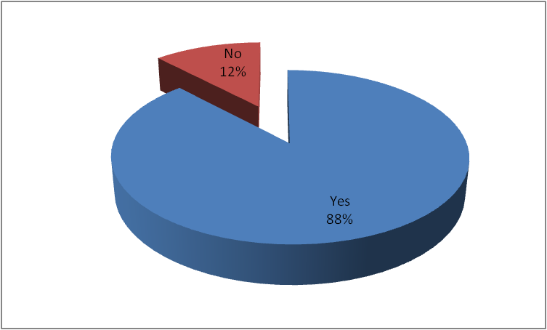

Figure 6 : All lecturers should use Learnonline

Of the 133 who have experience of online assessments, 14% (19) strongly agree that they put more time into their courses because of their lecturers’ usage of online assessments and quizzes compared to 51% (68) who somewhat agreed (65% = the somewhat agrees + the strongly agrees) (figure 7).

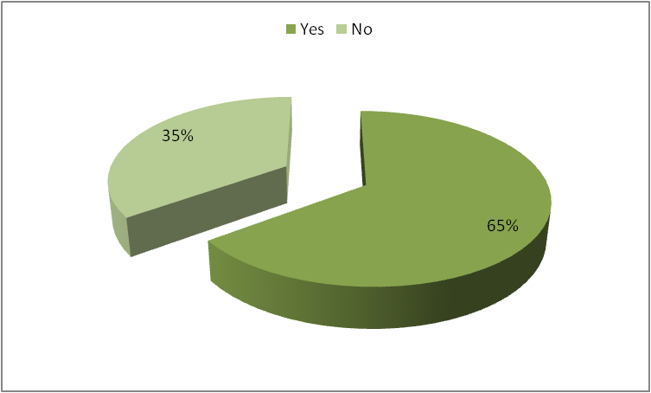

Figure 7 : I put a lot more time into my courses because of the online quizzes and/or assessments than I normally would

Of the respondents who have experience of Learnonline, the functionality most used is as follows (figure 8);
- Downloading lecture notes - 55% (309)
- Downloading assignments - 38% ( 214)
- Announcements - 22% (121)
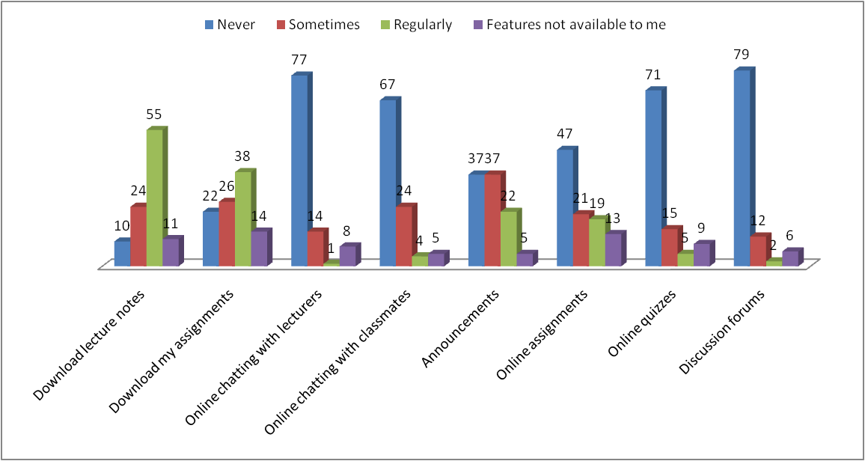
- Online assignments -19% (109)
Figure 8 : The features most used in Learnonline

Meanwhile, 5% (30) regularly use online quizzes, 4% (21) use the Learnonline functionality for online chatting with classmates, 2% (12) use the discussion forums and 1% (7) regularly chat online with lecturers. 79% (445) never use discussion forums, 77% (429) said that they never chat online with lecturers. 71% (396) said that they never use online quizzes and 67% (375) have never used Learnonline to chat online with their fellow classmates. Other features which respondents use (and which differ from those shown in figure 8) include; timetable, calendar, email, past exam papers and access to the library.

When asked what features they would like to see more regularly used, 90% (504) indicated that they are very interested in being able to download lecture notes, 62% (346) are most interested in announcements (regarding changes to timetables, assignment due dates etc.), 57% (320) are very interested in lecturers using the online assignment functionality in Learnonline, 35% (195) are very interested in online quizzes, 33% (186) prefer online chatting with lecturers whilst 28% (158) are very interested in discussion forums being used more regularly (figure 9).
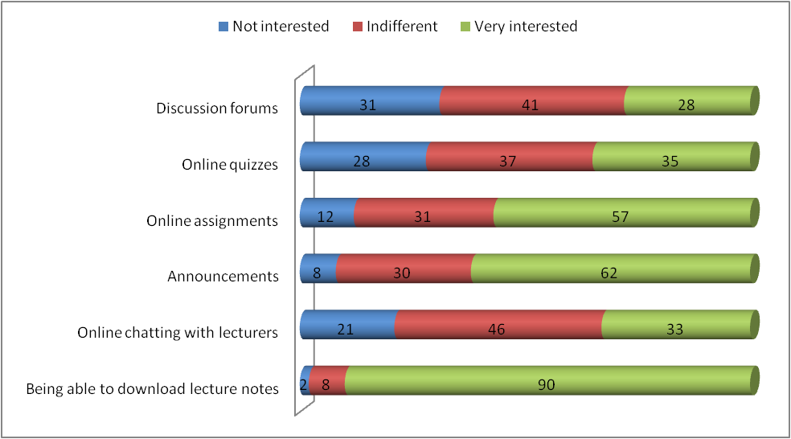
Figure 9 : Learnonline features I would like to see used more often

Of the 560 students who have experience of Learnonline, 46% (259) somewhat agreed that they learned better online than in traditional classrooms whilst 10% (57) strongly agreed that they learned better using this format (figure 10).
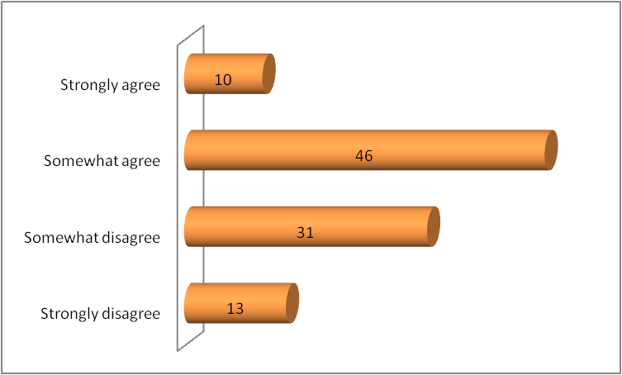

Figure 10 : I learned better online than in the traditional classroom

With regard to the respondents’ usage of social networks, the most popular and regularly used social networking platform is BEBO at 53% (364) with Youtube at 40% (271). Dixon et al. contend that the “growth of online technologies has resulted in the development of online social networks and the ability to communicate with others on a regular basis [Dixon, 2005]”. Student use social networks to overcome feelings of isolation.

Outside the college environment, 78% (542) regularly go on line at home. With the rollout of broadband, students generally do not go to internet cafes, as evidenced by 64% (446) who never go online in an internet café (figure 11).
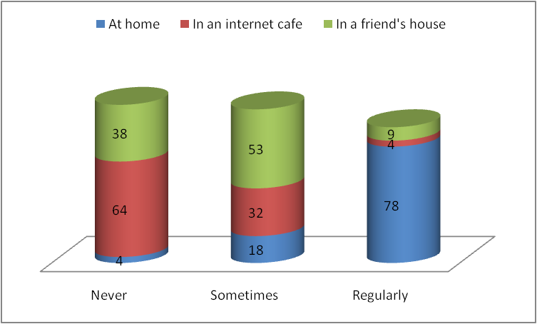

Figure 11 : Where do you go online?

Other places that the respondents go online include; work, parent’s house, wireless hotspots, student accommodation, pubs, mobile phones, hotels and local libraries. The majority of respondents indicated that they spend 1 to 2 hours online outside college – 37% (255) - whilst 25% (172) spend 2 to 3 hours online.

EFFECTIVE TEACHING

Elbe cites the characteristics of effective teachers to include mastery of the subject, competence, well prepared lectures, the use of real life examples, encouragement of students' questions, approachability, the provision of an immediate response to student questions and the provision of corrective feedback [Elbe, 1971]. Biggs argues that effective teaching results in the engagement of students in learning related activities [Biggs, 2006]. Glenn includes active teaching, the pacing of instruction, structured content and enthusiasm as the main components of good teaching [Glenn, 2001]. Effective teaching requires lecturers to be clear about the intended learning [Butcher, 2006]. Meanwhile, Seldin recognises the traits of effective teachers to include respect for students, the use of varied instructional formats, the engagement of the students, the provision of feedback, real life examples and clear guidelines concerning expectations for assignments, the ability to relate easily to students and the continual reflection on their own teaching performance [Seldin, 1989]. Ramsden includes enthusiasm, passion for the subject, the establishment of clear guidelines, respect for students, formative feedback and the ability to listen to students, as some of the characteristics of good teaching [Ramsden, 1995]. The HEA in the UK contends that an important aspect of effective teaching is effective feedback [Juwah, 2004].

STUDENTS’ VIEWS ON GOOD AND BAD TEACHING

In order to clearly present the students’ views on what constituted good and bad teaching, the survey findings are classified under the following headings,

- Communication – the ability to project the voice, clarity of speech, speed of talking etc.
- Feedback and grading –clarity of assignment/project guidelines, speed and comprehensiveness of critical feedback
- Knowledge – subject matter mastery, ability to answer questions
- Class participation and interaction – degree to which lecturers encourage and seek student participation and involvement in the class
- Presentation – presentation and explanation of the subject matter with regard to clarity, pace of delivery, use of relevant and relatable examples
- Students’ perspectives on lecturers’ personalities – how students perceive lecturers’ attitudes
- Concern for students – the approachability and helpfulness of lecturers towards students
- Discipline – punctuality, class control

All respondents provided at least one if not multiple comments on the question of what constituted good and bad teaching. Interestingly, 694 students gave more than 866 descriptions of what they believed comprised bad teaching compared with over 1000 descriptions of good teaching traits. From an analysis of the results regarding good teaching (see figure 12), students seemed to put more effort into describing behavior that cared about them, listened to their views, explained content, ensured that they understood before proceeding, was concerned about their progress, wanted them to do well and encouraged them to participate in class discussions. Students showed that they appreciated lecturers who are available, passionate about their subject, punctual, enthusiastic and knowledgeable. They welcome lecturers who put time and effort into the lecture, provide a clear course structure and set of guidelines as to what’s expected of them in assignments, return assignments on time and with good feedback and who are available and happy to help them. These results are commensurate with traits listed in literature; [Elbe, 1971], [Biggs, 2006], [Glenn, 2001], [Butcher, 2006], [Seldin, 1989], [Ramsden, 1995], [Juwah, 2004], [Gibson, 2006].

When students commented on bad teaching (figure 13), they focused primarily on the fast pace of delivery, the lecturers not ensuring that students understood before proceeding, unclear notes and bad explanations. Students also complained about lecturers who mumbled, waffled and were hard to hear. Those they considered bad teachers, they viewed as unconcerned with students’ needs, incapable of relating to students, unavailable, unpunctual, unhelpful and biased. Regarding the students’ perspectives on the personalities of bad teachers, the vehemence with which they described arrogant, unapproachable, moody and unlikeable lecturers was palpable.
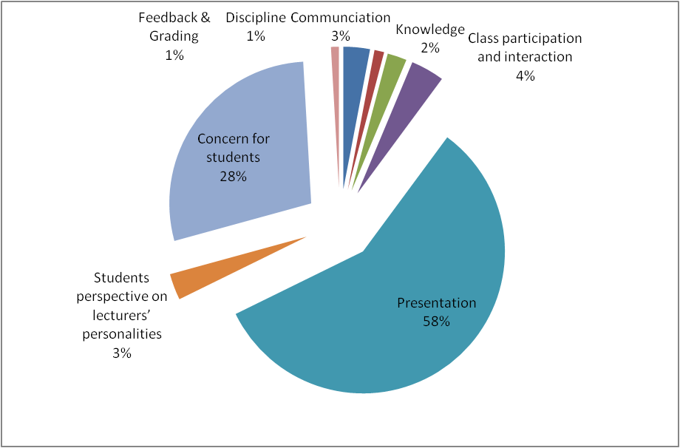
Figure 12 : Good teaching
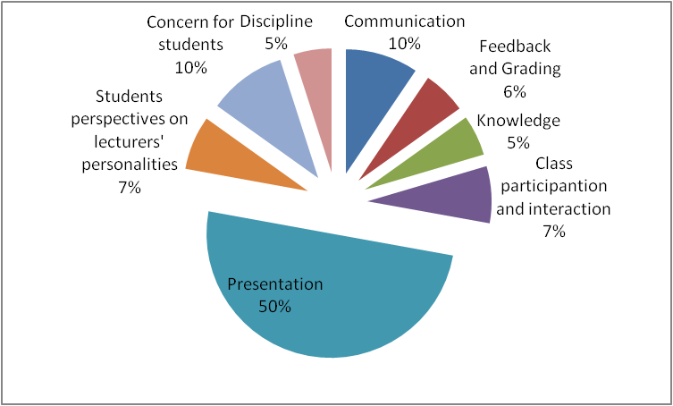
Figure 13 : Bad teaching
CONCLUSIONS & DISCUSSION POINTS

With a response rate of 14.1% (694 respondents), the online student survey has provided a set of interesting discussion points regarding students’ expectations and experiences of Moodle (branded Learnonline) and academic practise at GMIT. Whilst Learnonline is only in its second year of implementation, students in general are very satisfied with the technology. Of the 559 student respondents who have experience of Learnonline, 90% (the somewhat agrees + the strongly agrees) find it easy to use whilst 86% agree that it improved their overall learning experience. Meanwhile, 88% of all respondents said that all lecturers should be forced to use Learnonline. Currently, Learnonline is mostly used for downloading notes.

When questioned about their views on what constituted good and bad teaching, 694 students gave more than 866 descriptions of what they believed comprised bad teaching compared with over 1000 descriptions of good teaching traits.

Given the centrality of higher education to Ireland’s future success and the role of the student as the central focus of all higher education activities, it is incumbent on higher education institutions to provide quality teaching and learning, at both undergraduate and postgraduate levels. This survey of 694 students across all years and disciplines, has outlined prescriptive changes needed to improve teaching on a continuous basis. Regarding how effective we are in their eventual implementation, we will have to wait and ask the students, for they are the final authority of effective teaching and learning success.

REFERENCES

Allen, I. Elaine and Jeff Seaman. Online Nation : Five Years of Growth in Online Learning, Sloan Consortium, 2007.

Biggs, John. Teaching for Quality Learning at University, SRHE & Open University Press, 2006.

Butcher, C., Clara Davies and Melissa Highton, Designing Learning : From Module Outline to Effective Teaching, Routeledge, 2006.

Camp, John S., Peter B. DeBlois and the EDUCAUSE Current Issues Committee. Current Issues Survey Report, 2007, EDUCAUSE Quarterly, Number 2, 2007.

Conole, Grainne and Martin Oliver (editors). Contemporary Perspectives in E-Learning Research : Themes, Methods and Impact on Practice, Routledge, 2007.

Dixon, Kathryn, Lina Pelliccione and Robert Dixon. Differing Student Views of Online Learning Modes across programs in an Australian University, Campus Wide Information Systems, Volume 22, Number 3, 2005.

Eble, Kenneth. Components of Effective Teaching as Perceived by Students, in The Recognition and Evaluation of Teaching, 1971.

Ellis Robert A., Nerida Jarkey, Mary Jane Mahony, Mary Peat and Stephen Sheely. Managing Quality Improvement of eLearning in a Large Campus-based University, Quality Assurance in Education, Vol. 15 No. 1, 2007.

Fannon John and Brian D’Netto. “Cultural Diversity Online : Student Engagement with Learning Technologies”, International Journal of Educational Management, Volume 21, Number 5, pp. 418-432, 2007.

Gibson, Craig (ed.) Student Engagement and Information Literacy, Chicago IL, 2006.

Glenn, Robert E. Admirable Teaching Traits, National Education Association, 2001.

Hanno, John and Brian D’Netto. Cultural Diversity Online : Student Engagement with Learning Technologies, International Journal of Educational Management, Volume 21, Number 5, 2007.

HEA, 2008-2010. HEA Strategic Plan 2008 – 2010.
http://www.hea.ie/files/files/file/archive/policy/current/HEA%20Strategic%20Plan%202008%20-%202010%20EN.pdf (accessed 2 June, 2008)

HEA 2008. Minister Hanafin announces almost €100million for Higher Education Reform Process, Feb. 08.
http://www.hea.ie/index.cfm/page/news/category/134/section/details/id/364

Jackson, Michael. Serving Time : The Relationship of Good and Bad Teaching, Quality Assurance in Education, Volume 4, Number 4, pp. 385 – 397, 2006.

James, Richard. Students’ changing expectation of higher education and the consequences of mismatches with reality, OECD-IMHE conference; Management responses to changing student expectations, QUT, 24th September, 2001.

Juwah, C., D. Macfarlane-Dick, B. Matthew, D. Nichol, D. Ross and B. Smith. Enhancing Student Learning through Effective Formative Feedback, UK, HEA, 2004.

Kelly, Diana. Do you know what your students are learning? (And do you care?) in Emerging Issues in the practise of University Learning and Teaching, O’Neill, G, S. Moore, . Mc Mullin (ed.s), Dublin : AISHE, 2005.

Mohana, K. The use of e-Learning in Medial Education, postgraduate Medical Journal, Volume 83, 2007.

Ramsden, P, D. Margetson, E. Martin and S. Clarke. Recognising and Rewarding Good Teaching in Australia Higher Education, Australian Government Publishing Service, Canberra, 1995.

Roffe, Ian. E-Learning : Engagement, Enhancement and Execution, Quality Assurance in Education, Volume 10, Number 1, pp. 40 – 50, 2002.

Seldin, P. Using student feedback to improve teaching, New Directions for Teaching and Learning, Volume 37, pp. 89 – 97, 1989.

Taylor, Robert W. Pros and Cons of Online Learning – A Faculty perspective, Journal of European Industrial Training, Volume 26, Number 1, 2002.

USI. USI renews criticism of third-level underfunding, May 23, 2008
http://www.usi.ie/press/2008/05/23/usi-renews-criticism-of-third-level-underfunding/ (accessed June 2, 2008)

“Online enrolments have continued to grow at rates far in excess of the total higher education student population. Almost 3.5 million students were taking at least one online course. All types of institutions cite improved student access as their top reason for offering online courses and programs. Student demand for online learning is growing. Online education is critical to the long-term strategy of the institution. Online education is strategically important to increase student access and grow continuing and/or professional education [Allen, 2007]”.
Virtual Learning Environment
National Development Plan
The Union of students in Ireland also agree that “the more highly Ireland is educated, the better we will be able to weather the financial storms [USI, 2008].
Moodle is the VLE at GMIT
“e-Learning has had, and is continuing to have, a significant impact on both organizational structures and professional roles [Conole, 2007]”.
Gibson states that “one of the key challenges facing higher education today is student engagement [Gibson, 2006]”
Students complained about lecturers mumbling, waffling and being hard to hear. They lauded those who were good communicators and presenters
Students criticized lecturers who took forever to return assignments, didn’t provide feedback and didn’t outline exactly what was expected prior to the assignment.
Students praised those lecturers who had a mastery of their subject area, were able to answer questions clearly and understandably and who prepared them well for exams and assignments.
Students commended lecturers who actively sought student involvement and participation, listened to their opinions and checked that they understood the topic before proceeding.
Students were very disparaging of lecturers who delivered the material at an unrealistically fast pace, did not explain the content in an understandable manner, did not use relevant examples and provided unclear and messy notes.
Students commented that some lecturers were biased, condescending, un-motivated, un-likeable, sarcastic and mean.
Students spoke very well of those lecturers who encouraged them to do well, were always available to help, were concerned about them, related to and respected them.
Students grumbled about lecturers who were unpunctual, had no control over the class and were disorganised.

